

**THARAKA UNIVERSITY**

,

**COLLEGE**

**(A Constituent of College of Chuka University)**

**FACULTY OF SCIENCE, ENGINEERING AND TECHNOLOGY**

**DEPARTMENT OF COMPUTER SCIENCE AND ICT**

**PROJECT PROPOSAL**

**NAME: EISTEEN KIPLANGAT**

**REG NO: EDV2/04737/21**

**UNIT NAME: ICT PROJECT TWO**

**UNIT CODE: 0282**

**SERIES MAY/AUG**

**PROPOSAL TITLE**

**AUTOMATED ONLINE VOTING SYSTEM**

**SUPERVISOR:MARK KAMANJA**

**TABLE OF CONTENTS**

Dedication…………………………………………………..…. -

Acknowledgement…………………………………………...……

Abstract……………………………………………………..…….

**Chapter 1: INTRODUCTION**

* 1. background information--------------------------------------------
  2. problem statement---------------------------------------------------
  3. advantages of proposed system------------------------------------
  4. disadvantages of proposed system--------------------------------
  5. objectives-------------------------------------------------------------

1.5.1: general objective---------------------------------------------

1.5.2: specific objective--------------------------------------------

**CHAPTER 2: SCOPE OF STUDY----------------------------**

2.1: methodology---------------------------------------

2.1.1: interview--------------------------------------

2.1.2: observation------------------------------------

2.1.3: questionnaire----------------------------------

**CHAPTER 3: FEASIBILITY STUDY-----------------------**

3.1 operation feasibility-----------------------------

3.1.1 Schedule feasibility-----------------------------

3.1.2 Technical feasibility----------------------------

**CHAPTER 4 SYSTEM DESIGN------------------------------**

4.1: Data diagram/flowchart---------------------------------------------------------

**CHAPTER 5: RECOMMENDATION AND CONCLUSION---**

**Dedication**

I here declare that this project “**SCHOOL** **ONLINE VOTING SYSTEM** “is the work of Kip Langat Esteen in partial fulfillment of requirement for the award of the Diploma in information communication technology. I declare further that the work itself is mine.

Kiplangat Eisteen signature…………… date…………

Department of computer science

THARAKA UNIVERSITY COLLEGE.

**ACKNOWLEDGEMENT**

I would like to express my gratitude to mark kamanja who gave my support on understand and came out with a project, he guided me on how to tackle various fields on matters of coming up with this great project which will help me a lot as a develop some research skills.

I am also such much grateful for my parents who gave me all the resources and full support as I carried on with my research activity, for their great love and advice they are always giving me I must appreciate them all. Furthermore, I would like to thank the school library management for working tirelessly to ensure that we had enough resources to do our research.

**ABSTRACT**

The project describe the the problem undergone by the students during elections in their institutions’ project supports the idea of automated online school voting system kind of voting. The system itself comprised of a login button in which a student was supposed to log in order to access the system. The system was designed to allow a student to enter only once their registration numbers for them to and mark the preferred his or her choice.

**INTRODUCTION**

The project ‘**SCHOOL ONLINE VOTING SYSTEM** ‘manages the votingactivities in Tharaka university. The project itself can be tedious but easier and faster than the ballot box system of voting. It can be used in both top levels of education.

All the facilities for referring to voters (students)details are captured in the system, information can be updated, added, deleted, and save in the project.

The application can be capable and easily maintained. It could be easily changeable to the needs of the users.

**Background information.**

The automated school online voting system is a proposed system. It is a system that that is being used to vote online by the students in high institutions. This proposed system is improved in such a way that a student will only vote by entering his or her registration number after clicking on the login button. The voting process will be associated with the dean of students and the registrar. Since the proposed system is a web-based voting system, the management is able to identify problems mainly on students attempt to access access his or her portal whether he or she is eligible to vote or not after entering his or her details.

**ADVANTAGES OF THE PROPOSED SYSTEM**

It’s easy for the students to vote, hence saves on time

Its free from rigging since a student is permitted to vote only once by the system

Its saves on time since one is no papers are going to be marked but only to enter some student details like registration number.

**Disadvantages**

It requires high internet connection

It requires power

**Problem statement**

The existing system of voting has got a lot of drawbacks. It is slow since people have to que for a long period of time. Furthermore, the election is easily rigged since its possible that same ballot papers may be kept somewhere to be marked in the favor of one of the candidates

The newly initiated system of voting will be done online and this ensures that the elections carried out by students is free and fair free from rigging since when a student has voted his or her details will be captured by the system and he or she will not be able to vote twice, since the system is set to allow only voting to be done once.

**OBJECTIVE OF THE NEW SYSTEM**

**General objective**:

* To ensure faster and easy way of voting online

**Specific objective:**

* To ensure free and fair elections in school
* To minimize time wasted
* To minimize rigging
* To ensure that only student are eligible for voting

**SCOPE OF STUDY**

This is the documentation in which a project planning involves determining and documenting list of specific projects.

The automated school online voting system is used only in the high level of

The automation of the online school voting system manages the voting activities in the university since it does not allow foreigners to participate in the election process.

The scope thus has the task performed by; the clerk

The dean of students who is the chief officer

**METHODOLOGY**

During the research process, data was collected in various ways, it was found out the the existing system had a lot of problems. Such methods include;

1. **Interview**

It is a fact-finding technique whereby data collection is being collected from the individual through face-to-face interaction.

Data was collected from some of the students and also the student’s council leaders. The research was good since recognition of the problem facing them was identified.

There was also a great challenge during the interview since some of the students were not willing to be interviewed.

1. **Observation**

This is another method of data collection which was employed. It was obtained from students who were vying for different posts in the university in the last election, they reported that they were faced with a lot of challenges since the elections wasn’t free and fair, they said that there were rigging since many students were able to vote more than once.

**3.Questionaries**

This is a type of data collection whereby data was obtained by distributing papers to the students, staff and also none teaching staff containing some questions. The problem of the existing system of voting in the university was able to address through this method since the the questions were clearly answered.

1. **Email**

This is a method where the information about the existing system was given out by the students, teaching and none teaching staff to the dean of students and later the dean of students will later pass it the principal, The students gave out their Reponses vie their emails to the email of the dean

**FEASIBILITY STUDY**

Feasibility study is intended to to be premier review the facts to be see if it is worthy of proceeding to an

analysis phase

They are several types this include; operational and economic merits of proposed system

Feasibility analysis is an important tool for recommending whether to procced to merit phase or to discontinue with the project

**Operational feasibility**

This type of feasibility deals with how can users operate with the proposed system,

The proposed system should be very easy to the end users.

**Schedule feasibility**

It deals with whether the allocated and complete data can be met or not.

**Technical feasibility**

Feasibility which deals with It’s a type of whether the proposed system is technically present or not.

FLOWCHART

Is reg no valid?

Login

Database accessory

Not eligible to vote

Eligible to vote

Count vote

For him or her to be allowed by the system to vote. Once the registration number has been entered it becomes invalid if someone else try to enter it again since the system has been designed to allow only students to enter once this prevents the so-called rigging of votes and other malpractices which are not ass associated with free and fair elections in the universities.

**Output specification**

The proposed system has to take input, perform a process in order to produce an output based on given input

**Input specification**

After the test of the system is implemented to perform. Students are required to enter their registration numbers for them to access the system to vote for their preferred candidates. Once the registration number has been entered, the system won’t allow it to be entered again hence promotes transparency and a fair election.

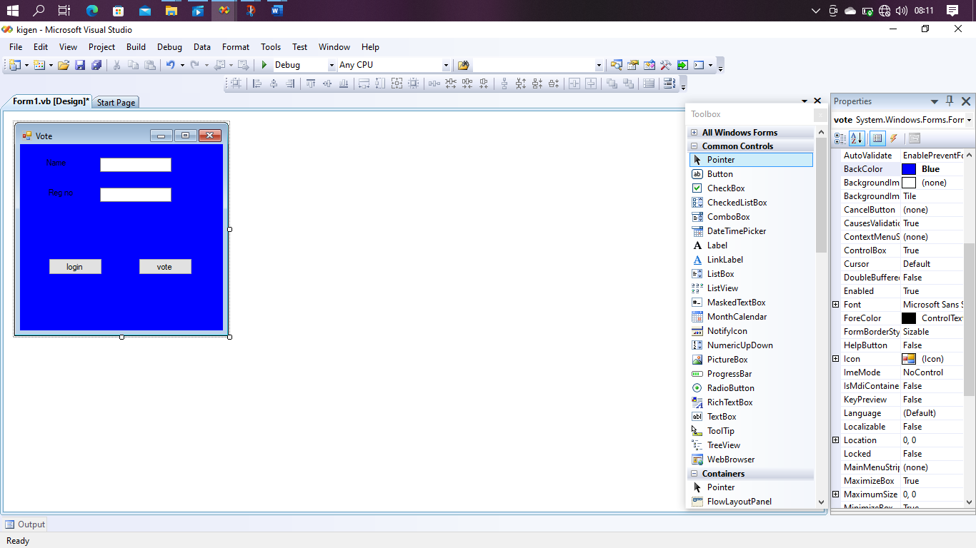

**RECOMMENDATION**

The issue encounter in the in the previous system recommends that;

From the interview carried out to collect some views from the students in the university, most of the said that there has been a lot of unfairness in terms of elections since same people who have been vying for different positions since from my research and the answers I was given by some students I got to interview them that most of the use bribes by involving even outsiders to vote in the election making it be unfair since they provide them with school ID’s them new system recommend that students will vote only and all the details will be captured successfully during the voting process, the main requirement is the student registration number.

**CONCLUSION.**

In conclusion, despite the advancement in technology online school voting system is faster than than the manual kind of voting that’s ballot box voting system where one has to take some time making and depositing them in the in respective ballot boxes.

From the study it’s evident that, the online voting system will work best if implemented.

To rest the point the system is developed and design for only academic purpose only.

**APPROVAL**

This project was submitted to the University Applied Science and technology for the school online voting system with approval of Mark Kamanja

Sign……………………………… Date……………………….

Department of computer science.

**APPENDIX**

Questionnaire No…………………………………

Name of interviewer………………………………

Date of interview……………………………….

Phone number……………………………………

Name of organization……………………………

Sex of the respondent……………………………

Age of the respondent………………………….